ABSTRACT

Sign languages, which have various regional variants, are used by thousands of people with hearing impairments around the world to communicate in their daily lives. Therefore, the automated translation of sign languages is seen as crucial and necessary for improving communication and inclusion for this group of people. However, there are several challenges that make this a difficult research area. One of the main challenges is the variability in sign language across regions, which makes it impractical to develop a standardized system. Nonetheless, sign language recognition technology has the potential to provide better services for the deaf community, bridging communication gaps and contributing to overall societal well-being. The project "Real-Time Hand Gesture Detection for Sign Language Recognition using Python" aims to develop a system that can recognize sign language gestures and translate them into text in real-time. The system uses computer vision techniques to detect and track hand movements, and machine learning algorithms to classify the gestures. Our proposed system can detect the classes of “Ok, Open Hand, Peace, Thumb and No Hand Detected”. The project will be implemented using the Python programming language and the OpenCV library for computer vision tasks. In our proposed system we develop two different portions where the first with the Xception architecture model to detect the images of the hand gestures and predict the results and the second with OpenCV to detect real time using web camera. Our proposed system with Xception architecture model achieved training accuracy of 99.34% and validation accuracy of 99.00%. The hand gesture recognition model will be trained using a dataset of hand gestures captured using a camera.The final system will provide a user-friendly interface to facilitate communication between sign language users and non-sign language users. It has the potential to improve communication and inclusivity for people with hearing or speech impairments in various settings such as classrooms, workplaces, and public spaces.

TABLE OF CONTENTS

|  |  |  |
| --- | --- | --- |
| **S.NO** | **TITLE** | **PAGE.NO** |
| **1** | **INTRODUCTION** | 1 |
| 1.1 | CONCEPT OF OVERVIEW | 3 |
| 1.2 | EXISTING SYSTEM | 3 |
| 1.3 | PROPOSED SYSTEM | 6 |
| **2** | **METHODOLOGY** | 8 |
| 2.1 | PROBLEM DEFINITION | 8 |
| 2.2 | OBJECTIVE OF THE PROJECT | 10 |
| 2.3 | BLOCK DIAGRAM OF PROJECT | 12 |
| 2.4 | SYSTEM REQUIRMENT | 13 |
| 2.5 | DEEP LEARNING | 14 |
| 2.6 | ALGORITHMS | 17 |
| **3** | **LANGUAGE TOOLS/DATASET** | 21 |
| 3.1 | LANGUAGES / TOOLS DESCRIPTION | 21 |
| 3.2 | LIBRARIES | 24 |
| **4** | **MODULE DESCRIPTION** | 32 |
| 4.1 | COLLECTION OF DATASET | 32 |
| 4.2 | PRE-PROCESSING OF DATA | 32 |
| 4.3 | FEATURE EXTRACTION | 32 |
| 4.4 | MODEL TRAINING | 32 |
| 4.5 | PREDICTION | 32 |
| 4.6 | POST PROCESSING | 32 |
| **5** | **SYSTEM ANALYSIS AND FEASIBILITY STUDY** | 33 |
| 5.1 | SYSTEM ANALYSIS | 33 |
| 5.2 | FEASIBILITY STUDY | 35 |
| **6** | **CONCLUSION** | 39 |
| **7** | **FUTURE ENHANCEMENT** | 40 |
| **8** | **BIBLIOGRAPHY** | 42 |
| **9** | **CODE DESIGN** | 43 |
| **10** | **RESULT AND DISCUSSION** | 46 |

|  |  |  |
| --- | --- | --- |
| Fig no | Figure name | Page no |
| 2.1 | block diagram | 12 |
| 2.2 | AI Architecture | 14 |
| 2.3 | Neural Network | 16 |
| 2.4 | CNN Architecture | 17 |
| 2.5 | Pooling Layer | 19 |
| 2.6 | Locally Connected Layer | 20 |
| 3.1 | Neural Network | 28 |
| 3.2 | Hand mapping | 28 |
| 4.1 | Use case diagram | 36 |

LIST OF FIGURES

CHAPTER 1

INTRODUCTION

* 1. CONCEPT OF OVERVIEW

Sign language detection using Convolutional Neural Networks (CNNs) represents a pivotal advancement in the realm of computer vision, particularly in facilitating communication for individuals with hearing impairments. This project endeavors to provide an in-depth exploration into the realm of sign language detection employing CNNs, offering a holistic understanding of the theoretical underpinnings, challenges, architectural considerations, and practical applications associated with this technology.

At its core, sign language detection involves deciphering hand gestures, facial expressions, and body movements to comprehend the intended message, making it a quintessential visual-gestural language utilized by the deaf and hard-of-hearing community. CNNs, as a subset of deep neural networks, offer a compelling framework for addressing the complexities inherent in this task. Renowned for their capacity to automatically learn hierarchical representations of visual data, CNNs excel in discerning patterns and features crucial for interpreting sign language gestures accurately.

However, the journey of sign language detection using CNNs is not devoid of challenges. Variability in hand shapes, orientations, and movements, coupled with background clutter and occlusions, poses formidable hurdles in achieving robust and accurate detection. Moreover, the demand for real-time performance necessitates the development of efficient algorithms capable of processing visual data swiftly and accurately.

The architecture of CNNs tailored for sign language detection typically comprises distinct layers, including input, convolutional, pooling, fully connected, and output layers. Each layer plays a pivotal role in extracting and processing features from the input data, culminating in classification based on the learned representations. Furthermore, the acquisition and preprocessing of annotated sign language datasets are crucial steps in training CNN models, encompassing techniques such as normalization, cropping, and augmentation to enhance dataset quality and diversity.

The training and evaluation phase of CNN models involve meticulous partitioning of datasets into training, validation, and test sets, followed by iterative optimization using backpropagation and optimization algorithms. The performance of the trained model is rigorously evaluated on the test set, employing metrics such as accuracy, precision, recall, and F1 score to gauge its efficacy in sign language detection tasks.

Beyond theoretical exploration, the practical implications of sign language detection using CNNs are profound. These technologies serve as the bedrock for developing assistive technologies, educational tools, and human-computer interaction systems aimed at fostering inclusivity and accessibility. By leveraging deep learning techniques, we can bridge the communication chasm between individuals with hearing impairments and the broader society, empowering them to communicate effectively and participate fully in various facets of life. This project serves as a foundational guide for researchers and practitioners embarking on the journey of building robust sign language detection systems using CNNs, with a vision of fostering a more inclusive and equitable society for all.on concatenated channels

* 1. EXISTING SYSTEM

In 2019, Akshay V and Deepak Kumar paper they desired to detect the each static and therefore the dynamic gesture accomplished via way of means of the person and they are constructing the python like syntax for the various instructions like if, if else with a minimal time of but a seconds through brooding about the essential programming keywords, through a custom-made dataset containing different pictures of the gesture like every word.

For detecting and processing gestures completed from the signing dictionary the utilization of a Convolution Neural Network version, and identify the phrases that are being communicated. They taken into consideration new technique for actual time control the utilization of the principal component analysis for gesture extraction and additionally for the sample popularity with the saved pictures Combining the strength of laptop imaginative and prescient and deep mastering algorithms which incorporates CNN that are tailor made one can expand structures that bridge the space among hearing, speech impaired people. Their cognizance is on monitoring hands and palms to achieve statistics approximately gestures.

They use a digicam-primarily based totally machine to report statistics approximately the gesture. This is often proposed from a 2D to 3-D area to optain broad information of an gesture. A Greedy Algorithm is employed to Predict necessary Frames and therefore the redundant predictions therefore the version can come to be ready to producing code of comparable to if and loop construction. The version has skilled on different pictures from the custom English-phrases dataset with some optimizer. This machine additionally handles one- passed and two passed gestures with inside the identical version. It’s likewise observed that a numerous and dataset with extra versions should make the version robust to sign versions, and improve significantly

1.2.1 DISADVANTAGES OF EXISTING SYSTEM:

* Limited Gesture Vocabulary: The system relies on a custom-made dataset containing different pictures of gestures for each word, which may result in a limited gesture vocabulary. This could potentially lead to difficulties in recognizing and interpreting a wide range of sign language gestures, including regional or individual variations in sign language.
* Dependency on 2D to 3D Conversion: The system proposes converting the gestures from 2D to 3D space to obtain a better understanding of the gestures. However, this conversion process may introduce additional complexities and potential inaccuracies, as it requires estimating the depth information from 2D images, which can be challenging and may not always be reliable.
* Greedy Algorithm for Prediction: The system uses a Greedy Algorithm for predicting necessary frames and eliminating redundant predictions. However, Greedy Algorithms are known for making locally optimal choices, which may not always result in the most accurate or optimal predictions. This could potentially impact the accuracy and reliability of the system's gesture recognition.
* Limited Optimization Techniques: The system mentions the use of an optimizer during training, but does not provide specific details on the optimization techniques employed. The choice of optimization algorithms and hyperparameter tuning can greatly impact the performance and accuracy of the deep learning model. The lack of detailed information on the optimization techniques used in the system may raise questions about the robustness and generalizability of the trained model.
* Potential Sensitivity to Variations: The system acknowledges that a diverse dataset with more variations could improve the model's robustness to sign language variations. However, the effectiveness of the model in handling different sign language variants, regional or individual sign language differences, or variations in hand shapes, movements, and orientations is not explicitly addressed. This could potentially limit the system's ability to accurately recognize and interpret a wide range of sign language gestures.
* Limited Mention of System Usability: The system does not provide explicit information about the usability or user-friendliness of the proposed system. Factors such as ease of use, system stability, latency, and user interface design can greatly impact the practical applicability and adoption of the system in real-world scenarios.
* Lack of Comparative Performance Evaluation: The system does not provide any comparative performance evaluation results with existing state-of-the-art systems or benchmark datasets. This makes it difficult to assess the performance and effectiveness of the proposed system in comparison to other similar systems or approaches.
* In conclusion, some potential disadvantages of the earlier system for hand gesture detection and sign language recognition may include limited gesture vocabulary, dependency on 2D to 3D conversion, use of a greedy algorithm for prediction, limited optimization techniques, potential sensitivity to variations, limited mention of system usability, and lack of comparative performance evaluation. Further research and improvements may be needed to address these limitations and enhance the system's accuracy, robustness, and usability.
  1. PROPOSED SYSTEM
* The proposed system aims to develop a real-time hand gesture detection system for sign language recognition using Python, specifically utilizing computer vision techniques and machine learning algorithms. The proposed system will be developed using the Python programming language and the OpenCV library for computer vision tasks. The Xception architecture model will be used for hand gesture recognition, which will be trained using a dataset of hand gestures captured using a camera.
* The proposed system will detect and classify hand gestures. The model will be trained on a dataset of hand gesture images, and it aims to achieve high accuracy in classifying gestures such as "Ok, Open Hand, Peace, Thumb, and No Hand Detected".
* The proposed system will utilize OpenCV to detect hand gestures in real-time using a web camera. Computer vision techniques will be used to track hand movements and extract relevant features for gesture recognition. The real-time hand gesture detection will be integrated with the trained model to provide accurate and fast recognition of sign language gestures. The proposed system will be evaluated based on its accuracy, real-time performance, and usability. Performance metrics such as accuracy, precision, recall, and F1-score will be used to evaluate the hand gesture recognition model. User feedback and usability testing will be conducted to assess the effectiveness and user-friendliness of the interface.

1.3.1 ADVANTAGES OF PROPOSED SYSTEM:

* Improved Communication and Inclusivity: The proposed system has the potential to improve communication for people with hearing or speech impairments by providing real-time sign language recognition. This can help bridge communication gaps and promote inclusivity in various settings such as classrooms, workplaces, and public spaces.
* Real-time Gesture Detection: The proposed system utilizes computer vision techniques and machine learning algorithms to enable real-time detection of hand gestures using a web camera. This allows for immediate recognition of sign language gestures, providing timely and efficient communication for users.
* Customizable and Extensible: The proposed system is developed using Python, a versatile and widely-used programming language, which allows for customization and extension according to specific requirements. This means that the system can be further improved, modified, or adapted to suit different sign language variants or specific user needs.
* User-friendly Interface: The proposed system aims to provide a user-friendly interface that facilitates communication between sign language users and non-sign language users. The interface can display recognized hand gestures as text or symbols, making it intuitive and easy to use, even for individuals without sign language knowledge.
* Potential for Various Applications: The proposed system has the potential to be used in various applications such as educational settings, workplaces, public spaces, and other communication scenarios where sign language recognition can be beneficial. This includes assisting deaf individuals in classrooms, facilitating communication in workplaces, or enabling communication with hearing-impaired individuals in public services, among others.
* Contribution to Societal Well-being: By improving communication and inclusivity for people with hearing or speech impairments, the proposed system has the potential to contribute to overall societal well-being. It can help reduce barriers to communication, promote inclusivity, and enhance the quality of life for individuals with hearing or speech impairments.

CHAPTER 2

METHODOLOGY

2.1 PROBLEM DEFINITION

The problem definition for the sign language detection project is to develop a robust and efficient system capable of accurately recognizing and interpreting sign language gestures in real-time. Sign language serves as a primary mode of communication for individuals with hearing impairments, yet existing methods for sign language detection often face challenges in effectively interpreting the complex and diverse nature of sign gestures. The goal of this project is to address these challenges by leveraging Convolutional Neural Networks (CNNs) and deep learning techniques to develop a system that can automatically detect, classify, and interpret sign language gestures from input images or video frames.

* Target Sign Language: Define the specific sign language or sign vocabulary that the system will focus on. This could include American Sign Language (ASL), British Sign Language (BSL), or other regional sign languages.
* Scope of Gestures: Determine the scope of sign gestures to be detected and recognized by the system. This may include letters of the alphabet, numbers, common words, phrases, or even more complex expressions and sentences.
* Real-Time Detection: Emphasize the need for real-time detection capabilities to enable seamless communication between deaf individuals and non-signers in various contexts, such as face-to-face interactions, video conferencing, or digital communication platforms.
* Accuracy and Robustness: Highlight the importance of developing a system that achieves high levels of accuracy and robustness in recognizing sign language gestures across different signers, lighting conditions, backgrounds, and variations in hand shapes and movements.
* Accessibility and Inclusivity: Address the broader goal of enhancing accessibility and inclusivity for individuals with hearing impairments by developing a sign language detection system that can be deployed in practical applications, including assistive technologies, educational tools, and communication aids.
* The task of sign language detection using Convolutional Neural Networks (CNNs) addresses the critical need for bridging communication barriers faced by the hearing-impaired community. The primary goal is to develop an automated system capable of recognizing and interpreting hand gestures, thereby facilitating seamless communication between individuals proficient in sign language and those who are not.
* Central to this endeavor is the acquisition and preparation of a comprehensive dataset encompassing diverse sign language gestures representing alphabets, words, and phrases. The dataset must capture variations in hand shapes, orientations, and movements to ensure the robustness of the detection system. Annotation and preprocessing steps are crucial to maintain data consistency and quality throughout the training process.
* Selecting an appropriate CNN architecture tailored for sign language detection is paramount. The chosen architecture should effectively extract spatial features from hand gestures while balancing model complexity and computational resources. Training the CNN model involves optimizing hyperparameters and employing techniques like data augmentation and transfer learning to enhance performance and generalization capabilities.
* Real-time detection presents a significant challenge, necessitating optimization for inference speed without compromising accuracy. Integrating the trained CNN model with natural language processing or speech synthesis components enables the interpretation of detected gestures into understandable text or spoken language output. User interface design plays a crucial role in facilitating intuitive interaction for both hearing-impaired users and those interacting with the system, emphasizing clear feedback and instructions.
* Evaluation metrics such as accuracy, precision, recall, F1 score, and inference speed are utilized to assess the effectiveness and usability of the system. Ultimately, the development of a robust sign language detection system using CNNs aims to empower the hearing-impaired community by fostering inclusive communication and accessibility in diverse contexts.

2.2 OBJECTIVE OF THE PROJECT

* Develop a Comprehensive Dataset: Acquire or create a comprehensive dataset of annotated sign language gestures, encompassing a diverse range of signs, variations in hand shapes, orientations, and movements, as well as different lighting conditions and backgrounds. This dataset will serve as the foundation for training and evaluating the sign language detection system.
* Explore Advanced CNN Architectures: Investigate and experiment with advanced CNN architectures, including deep architectures such as ResNet, DenseNet, and efficient architectures like MobileNet. Customize and optimize these architectures to suit the specific requirements of sign language recognition, ensuring scalability and efficiency in model training and inference.
* Augment Data for Robustness: Augment the dataset with techniques such as rotation, scaling, translation, and noise addition to enhance its diversity and robustness. Data augmentation helps in improving the generalization capabilities of the CNN model, making it more robust to variations in real-world scenarios.
* Implement Transfer Learning: Explore transfer learning techniques to leverage pre-trained CNN models, such as those trained on large-scale image datasets like ImageNet. Fine-tune these pre-trained models on the sign language dataset to accelerate training and improve performance, especially in cases of limited data availability.
* Optimize Training Strategies: Evaluate and optimize training strategies, including batch size, learning rate scheduling, and regularization techniques, to improve convergence speed and prevent overfitting. Experiment with different optimization algorithms such as Adam, RMSprop, and SGD with momentum to find the most suitable approach for training the CNN model.
* Integrate Real-time Processing: Develop a real-time sign language detection pipeline capable of processing input video streams or sequences of images in real-time. Implement efficient algorithms for gesture localization and tracking to ensure timely and accurate detection of sign language gestures.
* Evaluate Performance Metrics: Assess the performance of the sign language detection system using a comprehensive set of evaluation metrics, including accuracy, precision, recall, F1 score, and confusion matrices. Conduct cross-validation and hold-out validation to validate the robustness and generalization capabilities of the CNN model.
* Deploy in Practical Applications: Deploy the sign language detection system in practical applications, including assistive technologies, educational tools, and communication aids. Conduct usability testing and gather feedback from users to evaluate the system's effectiveness, user-friendliness, and overall impact on accessibility and inclusivity.
* Document and Disseminate Results: Document the methodology, implementation details, and findings of the sign language detection project in research papers, technical reports, and presentations. Share the system code, dataset, and resources with the research community to encourage collaboration, replication, and further advancements in the field.

2.3 BLOCK DIAGRAM OF THE PROJECT

Input Real Time video from Webcamera

Input image Dataset

Preprocessing

Training dataset

Testing Data

Prediction/Classification

Predicted Results: 'No Hand Detected', 'okay', 'Open Hand',' Peace',' Thumb

Fig 2.1 Block diagram

2.4 HARDWARE AND SOFTWARE SPECIFICATION

HARDWARE SPECIFICATION

Device name : SANJAY

Processor : AMD Ryzen 5 5600H with Radeon Graphics 3.30 GHz

Installed RAM : 8.00 GB (7.41 GB usable)

Device ID : F09258BD-EAC8-42EF-BB01-94603C507BCB

Product ID : 00327-30000-00000-AAOEM

System type : 64-bit operating system, x64-based processor

Pen and touch No pen or touch input is available for this display

SOFTWARE SPECIFICATION

Edition Windows 11 Home Single Language

Version 22H2

Installed on ‎3/‎30/‎2024

OS build 22621.3374

Experience Windows Feature Experience Pack 1000.22688.1000.0

2.5 deep learning

Deep learning is a subset of machine learning focused on algorithms inspired by the structure and function of the human brain's neural networks. It employs artificial neural networks with multiple layers to process and learn from vast amounts of data. Deep learning algorithms autonomously discover intricate patterns and representations within the data, enabling them to make predictions, recognize objects in images, understand speech, translate languages, and perform other complex tasks. This technology has revolutionized various fields such as computer vision, natural language processing, speech recognition, and medical diagnostics, driving advancements in artificial intelligence and enabling solutions to previously intractable problems.

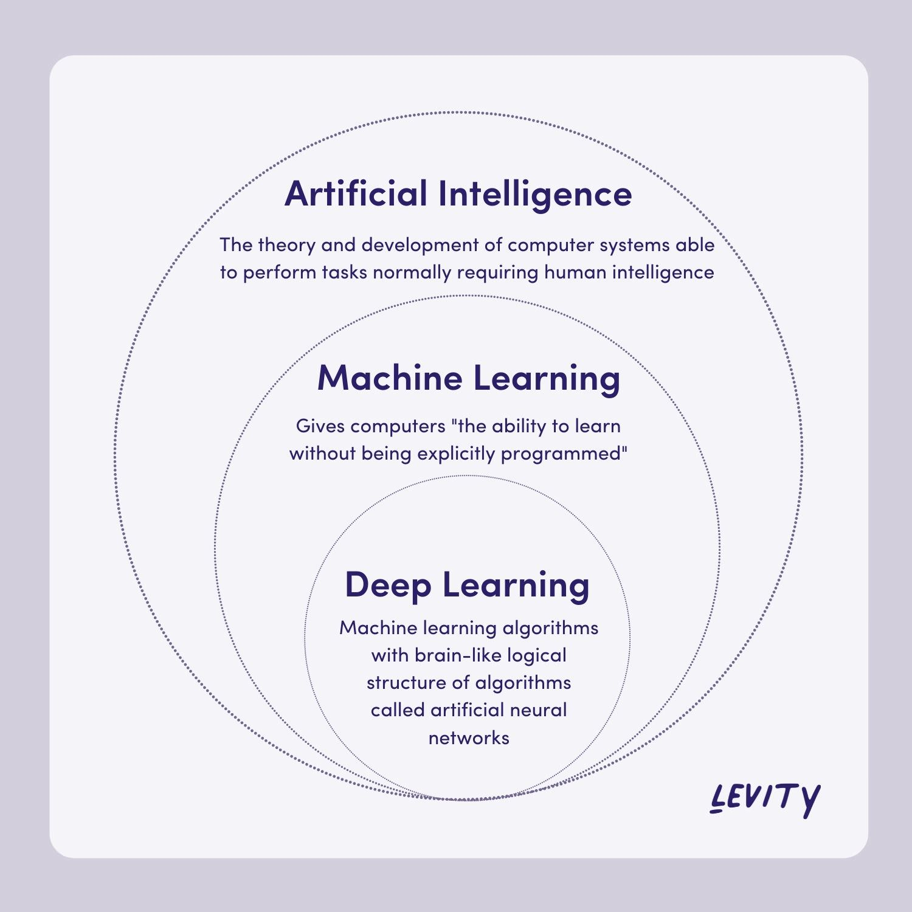

Fig 2.2 AI Architecture

These deep architectures have revolutionized various fields, achieving remarkable performance in tasks such as image recognition, natural language processing, and speech recognition. Deep learning models excel in capturing complex relationships in data, making them increasingly popular across industries. Types of Deep Learning:

* **Convolutional Neural Networks (CNNs):** CNNs are primarily used for processing and analyzing visual data, such as images and videos. They consist of multiple layers, including convolutional layers, pooling layers, and fully connected layers. CNNs excel at capturing spatial hierarchies of features, enabling tasks like object detection, image classification, and semantic segmentation.
* **Recurrent Neural Networks (RNNs):** RNNs are designed to handle sequential data by maintaining internal memory. This architecture allows RNNs to capture temporal dependencies in sequential data, making them well-suited for tasks like speech recognition, language modeling, and time series prediction. However, traditional RNNs suffer from the vanishing gradient problem, which limits their ability to capture long-range dependencies.
* **Long Short-Term Memory Networks (LSTMs) and Gated Recurrent Units (GRUs):** LSTMs and GRUs are specialized variants of RNNs designed to address the vanishing gradient problem. They incorporate gated mechanisms to regulate the flow of information within the network, allowing them to capture long-term dependencies more effectively. LSTMs and GRUs are widely used in tasks requiring memory over long sequences, such as machine translation, sentiment analysis, and speech synthesis.
* **Generative Adversarial Networks (GANs):** GANs consist of two neural networks, a generator and a discriminator, trained simultaneously in a game-theoretic framework. The generator aims to generate realistic data samples, while the discriminator attempts to distinguish between real and fake samples. Through adversarial training, GANs learn to generate high-quality synthetic data, making them valuable for tasks like image generation, data augmentation, and anomaly detection.
* **Auto encoders**: Auto encoders are unsupervised learning models designed to learn efficient representations of input data by reconstructing it through a bottleneck layer. The encoder compresses the input into a latent representation, while the decoder reconstructs the original input from the latent representation. Auto encoders have applications in dimensionality reduction, feature learning, and de-noising tasks.
* **Transformers**: Transformers are a class of models based on self-attention mechanisms, originally introduced for natural language processing tasks. Unlike traditional sequence-based architectures like RNNs, transformers process entire sequences in parallel, making them highly parallelizable and efficient for long-range dependencies. Transformers have achieved state-of-the-art performance in tasks such as machine translation, text summarization, and language understanding.

Deep learning continues to advance rapidly, driven by innovations in model architectures, optimization techniques, and hardware acceleration. Understanding the diverse types of deep learning architectures empowers practitioners to choose the most suitable approach for their specific tasks, unlocking the full potential of deep learning in solving real-world problems across various domains.

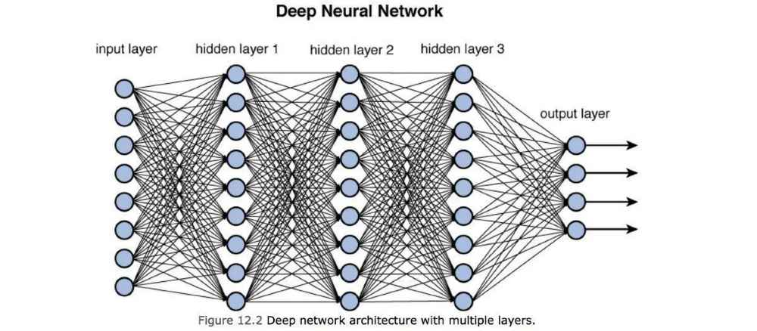

**Fig 2.3 Neural Network**

2.6 ALGORITHMS

**CONVOLUTIONAL NEURAL NETWORK**

**Fig 2.4 CNN-Architecture**

Convolutional Neural Networks (CNNs) are a class of deep neural networks primarily designed for processing and analyzing visual data. They have revolutionized tasks such as image recognition, object detection, and image segmentation due to their ability to automatically learn hierarchical representations directly from raw pixel data. CNNs leverage convolutional layers, pooling layers, and fully connected layers to extract meaningful features from images, enabling robust and efficient learning. Types of Convolutional Neural Networks:

* **Traditional CNNs**: Traditional CNN architectures consist of a sequence of convolutional layers followed by pooling layers and fully connected layers. Examples include LeNet-5, Alex-Net, VGG-Net, and Google-Net (Inception). These networks laid the foundation for modern deep learning in computer vision tasks and are still used as benchmarks for comparison.
* **Residual Networks (Res-Nets)**: Res-Nets introduced residual connections, also known as skip connections, to address the degradation problem encountered in deeper networks. By allowing the flow of gradients through shortcuts, Res-Nets facilitate the training of very deep networks, leading to improved performance. Res-Nets have won numerous competitions and are widely used in various applications.
* **Inception Networks**: Inception networks, such as Google-Net, employ inception modules comprising multiple parallel convolutional operations with different kernel sizes and strides. This architecture aims to capture features at multiple scales efficiently, enabling the network to achieve both high accuracy and computational efficiency.
* **Xception Networks**: Xception networks take the idea of Inception networks further by replacing the standard convolutional layers with depth wise separable convolutions. This architecture separates the spatial and channel-wise transformations, reducing the number of parameters and computational cost while maintaining performance. Xception networks excel in scenarios with limited computational resources.
* **Densely Connected Networks (Dense-Nets)**: Dense-Nets introduce dense connectivity between layers, where each layer receives feature maps from all preceding layers as inputs. This densely connected architecture encourages feature reuse, facilitates gradient flow, and alleviates the vanishing gradient problem. Dense-Nets achieve state-of-the-art performance with improved parameter efficiency and feature propagation.

**Working of CNN**

* **Input:** If the image consists of 32 widths, 32 height encompassing three R, G, B channels, then it will hold the raw pixel([32x32x3]) values of an image.
* **Convolution:** It computes the output of those neurons, which are associated with input's local regions, such that each neuron will calculate a dot product in between weights and a small region to which they are actually linked to in the input volume. For example, if we choose to incorporate 12 filters, then it will result in a volume of [32x32x12].
* **ReLU Layer:** It is specially used to apply an activation function elementwise, like as max (0, x) thresholding at zero. It results in ([32x32x12]), which relates to an unchanged size of the volume.
* Pooling: This layer is used to perform a downsampling operation along the spatial dimensions (width, height) that results in [16x16x12] volume.

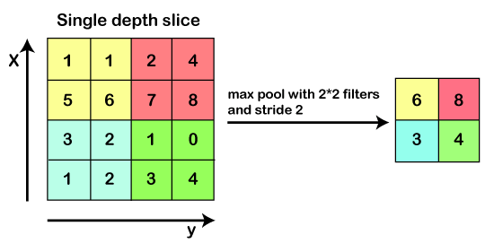

Fig 2.5 Pooling Layer

* Locally Connected: It can be defined as a regular neural network layer that receives an input from the preceding layer followed by computing the class scores and results in a 1-Dimensional array that has the equal size to that of the number of classes.

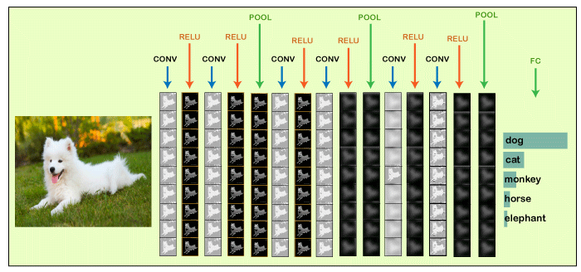

**Fig 2.6 Locally Connected Layer**

Convolutional Neural Networks and their variants continue to evolve, driven by advancements in model architectures, optimization techniques, and hardware acceleration. Understanding the principles and types of CNNs empowers researchers and practitioners to design and deploy effective solutions for a wide range of computer vision tasks, contributing to advancements in artificial intelligence and beyond.

Conclusion

Convolutional Neural Networks differ to other forms of Artifical Neural Network in that instead of focusing on the entirety of the problem domain, knowledge about the specific type of input is exploited. This in turn allows for a much simpler network architecture to be set up.This paper has outlined the basic concepts of Convolutional Neural Networks,explaining the layers required to build one and detailing how best to structure the network in most image analysis tasks.Research in the field of image analysis using neural networks has somewhat slowed in recent times. This is partly due to the incorrect belief surrounding the level of complexity and knowledge required to begin modelling these superbly powerful machine learning algorithms. The authors hope that this paper has in some way reduced this confusion, and made the field more accessible

CHAPTER 3

LANGUAGE TOOLS/DATASET

3.1 LANGUAGES/TOOLS DESCRIPTION

INTRODUCTION TO PYTHON

1. ****Overview****:
   * ****High-Level and Interpreted****: Python is a high-level language, which means it abstracts complex details and allows developers to focus on solving problems. It’s also an interpreted language, meaning you don’t need to compile code before running it.
   * ****General-Purpose****: Python is not specialized for any specific domain; it can be used for a wide range of applications.
   * ****Guido van Rossum****: Python was created by Guido van Rossum in 1991, and its development continues through a collaborative community effort.
2. ****Key Features****:
   * ****Readability****: Python emphasizes clean and concise code. Its syntax uses indentation (whitespace) to define code blocks, making it highly readable.
   * ****Rich Standard Library****: Python comes with an extensive standard library that provides modules for various tasks, from file I/O to web development.
   * ****Dynamic Typing****: Variables are dynamically typed, allowing flexibility during runtime.
   * ****Object-Oriented and Functional****: Python supports both object-oriented and functional programming paradigms.
   * ****Cross-Platform****: Python runs on various platforms (Windows, macOS, Linux) without modification.
   * ****Community and Ecosystem****: A vibrant community contributes to open-source libraries and frameworks, making Python suitable for diverse applications.
3. ****Common Use Cases****:
   * ****Web Development****: Frameworks like Django, Flask, and FastAPI enable building web applications.
   * ****Data Science and Machine Learning****: Libraries like NumPy, Pandas, and scikit-learn facilitate data analysis, machine learning, and scientific computing.
   * ****Automation and Scripting****: Python is excellent for automating repetitive tasks, managing files, and writing scripts.
   * ****GUI Development****: Libraries like tkinter, PyQt, and wxPython create graphical user interfaces.
   * ****System Administration****: Tools like Ansible and Salt use Python for configuration management.
   * ****Game Development****: Pygame and Panda3D support game development.
   * ****Networking and APIs****: Python is widely used for creating RESTful APIs and handling network communication.
4. ****Python Enhancement Proposals (PEPs)****:
   * PEPs are proposals for adding features or making changes to Python. They guide the language’s evolution.
   * Example: PEP 8 defines the style guide for writing Python code.
5. ****Community and Resources****:
   * The [Python Software Foundation](https://www.python.org/) oversees Python’s development and promotes its growth.
   * Python’s official documentation provides detailed information about the language and its standard library.
   * The community actively shares knowledge through forums, blogs, and conferences.
6. Pythonic Syntax and Readability:
   * Python’s syntax emphasizes readability and simplicity.
   * Code blocks are defined by indentation (whitespace), making it visually clean.
7. Data Types and Variables:

* Integers: Whole numbers (e.g., 42, -10).
* Floats: Decimal numbers (e.g., 3.14, -0.5).
* Strings: Text (e.g., "Hello, World!").
* Lists: Ordered collections (e.g., [1, 2, 3]).
* Dictionaries: Key-value pairs (e.g., {"name": "Alice", "age": 30}).

1. Libraries and Ecosystem:

* NumPy: For numerical computations.
* Pandas: Data manipulation and analysis.
* Matplotlib and Seaborn: Data visualization.
* scikit-learn: Machine learning.
* Requests: HTTP requests.

3.2 LIBRARIES

Real-time Hand Gesture Recognition using TensorFlow & OpenCV

Gesture recognition is an active research field in Human-Computer Interaction technology. It has many applications in virtual environment control and sign language translation, robot control, or music creation. In this machine learning project on Hand Gesture Recognition, we are going to make a real-time Hand Gesture Recognizer using the MediaPipe framework and Tensorflow in OpenCV and Python. OpenCV is a real-time Computer vision and image-processing framework built on C/C++. But we’ll use it on python via the OpenCV-python package.

3.2.1 MediaPipe

Getting Started:

Explore the MediaPipe developer guides for vision, text, and audio tasks.Set up development environments for Android, web apps, and Python.Remember, MediaPipe simplifies ML integration, making it accessible to a wide range of developers!

Purpose and Scope:

MediaPipe Solutions provides a suite of libraries and tools for rapid application of artificial intelligence (AI) and ML techniques.Developers can seamlessly incorporate these solutions into their applications, customize them to their specific requirements, and deploy them across various platforms.

Key Features:

* + Cross-Platform Deployment: MediaPipe caters to mobile (Android, iOS), web, desktop, edge devices, and IoT.
  + Pre-Trained Models: It includes ready-to-use, pre-trained models for various tasks.
  + Customization: Developers can fine-tune models using their own data with MediaPipe ModelMaker.
  + Visualization and Evaluation: MediaPipe Studio allows visualizing, evaluating, and benchmarking solutions in the browser.

Components:

MediaPipe Tasks : Cross-platform APIs and libraries for deploying solutions.

MediaPipe Models : Pre-trained models for each solution.

MediaPipe Framework: Low-level component for building efficient on-device ML

pipelines.

3.2.2 Tensorflow

TensorFlow is an open-source library for machine learning and deep learning developed by the Google brains team. It can be used across a range of tasks but has a particular focus on deep neural network.

****What is TensorFlow****

* TensorFlow is designed to build and train **deep learning models**. It provides a flexible framework for creating **computational graphs** and efficiently executing them on various hardware platforms.
* The library is entirely based on the **Python programming language** and is widely used for numerical computation and data flow.
* [Released by the **Google Brain Team** on **November 9, 2015**, TensorFlow has since become a go-to tool for machine learning practitioners and researchers](https://www.javatpoint.com/tensorflow-introduction)

1. ****Key Features and Concepts:****

* **Computational Graphs**: TensorFlow models are represented as computational graphs. These graphs consist of nodes (representing mathematical operations) and edges (representing data arrays or tensors).
* **Nodes and Tensors**: Nodes perform operations, and tensors are the central units of data in TensorFlow.
* **Session**: To evaluate nodes, we create a session that encapsulates the control and state of the TensorFlow runtime.

1. ****Use Cases****:

* TensorFlow is widely used for:
* **Image recognition**: Building and training deep neural networks for tasks like image classification.
* **Speech recognition**: Developing models that understand spoken language.
* **Natural language processing (NLP)**: Analyzing and generating human language.
* [**Predictive modeling**: Creating models for regression, classification, and recommendation systems](https://www.javatpoint.com/tensorflow-introduction)

1. ****Keras Integration****:
   * TensorFlow’s APIs use **Keras** as a high-level interface. Keras simplifies model building and allows users to create custom machine learning models.
   * [TensorFlow also handles data loading, training, and deployment using **TensorFlow Serving**](https://en.wikipedia.org/wiki/TensorFlow) 
     1. OpenCV
2. Computer Vision Algorithms: OpenCV offers a plethora of algorithms for various computer vision tasks. Some notable ones include:
   * Edge Detection: Algorithms like Canny, Sobel, and Laplacian help identify edges in images.
   * Image Filtering: You can apply filters like Gaussian blur, median blur, and bilateral filter to enhance or denoise images.
   * Image Morphology: Techniques like erosion, dilation, opening, and closing are useful for shape analysis.
   * Feature Matching: OpenCV provides methods for matching features between images.
   * Optical Flow: Algorithms like Lucas-Kanade and Farneback estimate motion between consecutive frames in videos.
   * Stereo Vision: For depth estimation using stereo camera pairs.
   * Face Detection: Haar cascades and deep learning-based models (like DNN) can detect faces.
   * Object Tracking: Algorithms like MeanShift and CamShift track objects across frames.
   * Background Subtraction: Useful for detecting moving objects in video streams.
   * Camera Calibration: Estimate camera parameters for accurate 3D reconstruction.
   * Histograms: Compute histograms for image analysis.
   * Contour Detection: Identify contours in binary images.
   * Hough Transform: Detect lines and circles in images.
   * Image Stitching: Combine multiple images to create panoramas.
   * Superpixels: Divide an image into compact, perceptually meaningful regions.
   * Deep Learning Models: OpenCV integrates with pre-trained neural networks for tasks like image classification and segmentation.
3. Machine Learning Integration: OpenCV’s ML module includes tools for training and using machine learning models. You can perform tasks like classification, regression, clustering, and more.
4. Performance Optimization: OpenCV is optimized for speed and efficiency. It leverages hardware acceleration (such as Intel IPP, TBB, and CUDA) to process images faster.
5. Python and C++ Interfaces: OpenCV provides APIs in both Python and C++. You can choose the language that suits your needs.
6. Community and Documentation: OpenCV has a vibrant community, and its documentation is extensive. You’ll find tutorials, examples, and detailed explanations for each function.

Neural Networks are also known as artificial neural networks. It is a subset of machine learning and the heart of deep learning algorithms. The concept of Neural networks is inspired by the human brain. It mimics the way that biological neurons send signals to one another. Neural networks are composed of node layers, containing an input layer, one or more hidden layers, and an output layer.

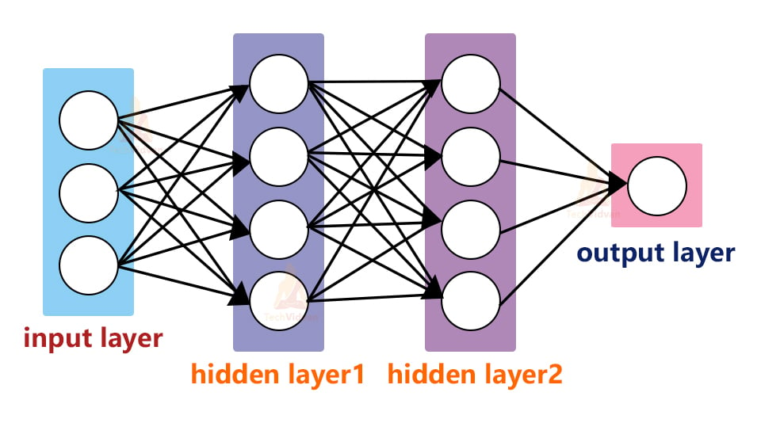

Fig 3.1 Neural Network

We’ll first use MediaPipe to recognize the hand and the hand key points. MediaPipe returns a total of 21 key points for each detected hand.

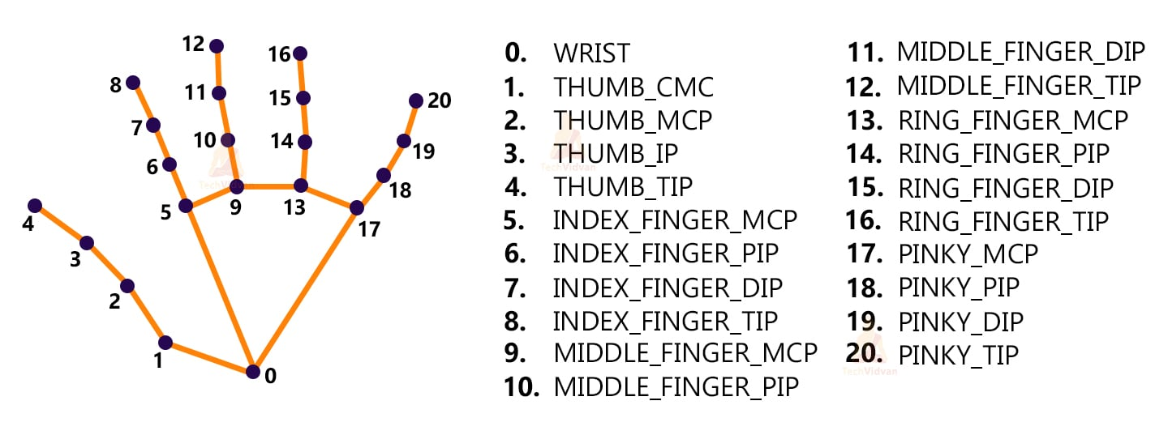

Fig 3.2 Hand mapping

These key points will be fed into a pre-trained gesture recognizer network to recognize the hand pose.

Steps to solve the project:

* Import necessary packages.
* Initialize models.
* Read frames from a webcam.
* Detect hand keypoints.
* Recognize hand gestures.

Step 1 – Import necessary packages

To build this Hand Gesture Recognition project, we’ll need four packages. So first import these.

Step 2 – Initialize models

Mp.solution.hands module performs the hand recognition algorithm. So we create the object and store it in mpHands. Using mp Hands.Hands method we configured the model. The first argument is max_num_hands, that means the maximum number of hand will be detected by the model in a single frame. MediaPipe can detect multiple hands in a single frame, but we’ll detect only one hand at a time in this project. Mp.solutions.drawing_utils will draw the detected key points for us so that we don’t have to draw them manually.

Initialize Tensorflow

Using the load_model function we load the TensorFlow pre-trained model.

Gesture.names file contains the name of the gesture classes. So first we open the file using python’s inbuilt open function and then read the file.

After that, we read the file using the read() function.

Output :

[‘okay’, ‘peace’, ‘thumbs up’, ’no hand detection’, ‘open hand’]

The model can recognize 5 different gestures.

Step 3 – Read frames from a webcam:

We create a VideoCapture object and pass an argument ‘0’. It is the camera ID of the system. In this case, we have 1 webcam connected with the system. If you have multiple webcams then change the argument according to your camera ID. Otherwise, leave it default.

The cap.read() function reads each frame from the webcam.

cv2.flip() function flips the frame.

cv2.imshow() shows frame on a new openCV window.

The cv2.waitKey() function keeps the window open until the key ‘q’ is pressed

Step 4 – Detect hand keypoints:

MediaPipe works with RGB images but OpenCV reads images in BGR format. So, using cv2.cvtCOLOR() function we convert the frame to RGB format.The process function takes an RGB frame and returns a result class.Then we check if any hand is detected or not, using result.multi_hand_landmarks method.After that, we loop through each detection and store the coordinate on a list called landmarks. Here image height (y) and image width(x) are multiplied with the result because the model returns a normalized result. This means each value in the result is between 0 and 1.And finally using mpDraw.draw_landmarks() function we draw all the landmarks in the frame.

Step 5 – Recognize hand gestures:

The model.predict() function takes a list of landmarks and returns an array contains 10 prediction classes for each landmark.The output looks like thisNp.argmax() returns the index of the maximum value in the list.After getting the index we can simply take the class name from the classNames list.Then using the cv2.putText function we show the detected gesture into the frame.

CHAPTER – 4

MODULE DESCRIPTION

* 1. Data Collection:

This involves creating a dataset for sign language detection. It could involve capturing images or videos of different sign language gestures. The data can be collected from a live feed from a video cam and every frame that detects a hand in the region of interest (ROI) can be saved in a directory

* 1. Preprocessing:

This step involves preparing the data for the model. It could involve resizing images, normalizing pixel values, segmenting the hand region, and more

* 1. Feature Extraction:

This module is responsible for extracting relevant features from the preprocessed data. These features are then used by the model to learn the patterns associated with different signs

4.4Model Training:

This involves training a machine learning or deep learning model on the extracted features. The model could be a Convolutional Neural Network (CNN), Recurrent Neural Network (RNN),or any other suitable model

* 1. Prediction: This module uses the trained model to predict the sign language gestures in new, unseen data
  2. Post-processing: This step involves interpreting the model’s predictions and converting them into

understandable outputs

4.7 SYSTEM ANALYSIS

###### **INTRODUCTION**

System Analysis and Design, is the process of gathering and interpreting facts, diagnosing problem and using the information to recommend improvement to the system. Before development of any project can be pursued, a system study is conducted to learn the details of the current business solution. Information gathered through the study forms the basis for creating alternative design strategies. Virtually all organizations are systems that interact with their environment through receiving input and producing output. It is a management technique used in designing a new system, improving an existing system or solving problem. System analysis does not guarantee that the user will derive an ideal solution to a problem. This depends solely on the way one design a system to exploit the potential in the method. To put it in another way, creativity is as much as must pre-design the study and problem solving process and evaluate every successive step in the system analysis.Taking all these factors into account and with the knowledge of the inter-relationship between the various fields and section and their potential interactions, they are consider for developing the whole system in and integrated manner, this project is developed to meet all the criteria in the The management technique is also helps us in develop and design of the new system or to improve the existing system.

The following Objectives are kept in mind:

* Identify the customer’s need.
* Evaluate the system concept for feasibility.
* Perform economic and technical analysis.
* Allocate functions to hardware, software, people, database and other system elements.
* Establish cost and schedule constraints
* Create a system definition that forms the foundation for all subsequent engineering work.

Identification of the need:

In this, there are certain expressions that are being used in the development of the project. And, it is used to identify our needs or source in the project.

* Defining a problem
* Finding the various need for the problem
* Formalizing the need
* Relating the need

Thus, it is the first step for system development life cycle.

**Initial Investigation**

It is one way of handling the project, it is used to know about the user request and the modification of the system should be done.

The user’s request for this project is as follows:

1. Assigning separate work area for different users.
2. Nature of the work
3. Regular update and delete of record
4. Regular calculation of Net Asset Value
5. Supplying the data with the time required.

The user request identifies the need for change and authorizes the initial investigation. It may undergo several modifications before it become a written commitment. Once approved the activities are carried out into action. The proposal, when approved, it initiates a detailed user-oriented specification of system performance and analysis of the feasibility of the evaluating alternative candidate systems with a recommendation of the best system for the job.

###### **4.8 Feasibility Study**

The objective of the feasibility study is not only to solve the problem but also to acquire a sense of its scope. The reason for doing this is to identify the most beneficial project to the organization.

There are three aspects in the feasibility study:

1. Technical Feasibility
2. Financial Feasibility
3. Operating Feasibility

**Technical Feasibility**

The Technical feasibility is the study of the software and how it is included in the study of our project. Regarding this there are some technical issues that should be noted they are as follows:

* Is the necessary technique available and how it is suggested and acquired?
* Does the proposed equipment have the technical capacity to hold the data required using the new system?
* Will the system provide adequate response that is made by the requester at an periodic time interval
* Can this system be expanded after this project development
* Is there a technique guarantees of accuracy, reliability in case of access of data and security

The technical issues are raised during the feasibility study of investigating our System. Thus, the technical consideration evaluates the hardware requirements, software etc. This system uses JSP as front end and Oracle as back end. They also provide sufficient memory to hold and process the data. As the company is going to install all the process in the system it is the cheap and efficient technique.

This system technique accepts the entire request made by the user and the response is done without failure and delay. It is a study about the resources available and how they are achieved as an acceptable system. It is an essential process for analysis and definition of conducting a parallel assessment of technical feasibility.

Though storage and retrieval of information is enormous, it can be easily handled by Oracle. As the oracle can be run in any system and the operation does not differ from one to another. So, this is effective.

Economical Feasibility

An organization makes good investment on the system. So, they should be worthful for the amount they spend in the system. Always the financial benefit and equals or less the cost of the system, but should not exceed the cost.

* The cost of investment is analyzed for the entire system
* The cost of Hardware and Software is also noted.
* Analyzing the way in which the cost can be reduced

Every organization want to reduce there cost but at the same time quality of the Service should also be maintained. The system is developed according the estimation of the cost made by the concern. In this project, the proposed system will definitely reduce the cost and also the manual work is reduced and speed of work is also increased.

Operational Feasibility

Proposed project will be beneficial only when they are turned into an information system and to meet the organization operating requirements. The following issues are considered for the operation:

* Does this system provide sufficient support for the user and the management?
* What is the method that should be used in this project?
* Have the users been involved in the planning and development of the projects?
* Will the proposed system cause any harm, bad result, loss of control and accessibility of the system will lost?

Issues that may be a minor problem will sometimes cause major problem in the operation. It is the measure of how people can able to work with the system. Finding out the minor issues that may be the initial problem of the system. It should be a user-friendly environment. All these aspect should be kept in mind and steps should be taken for developing the project carefully.

Regarding the project, the system is very much supported and friendly for the user. The methods are defined in an effective manner and proper conditions are given in other to avoid the harm or loss of data. It is designed in GUI interface, as working will be easier and flexible for the user. They are three basic feasibility studies that are done in every project.

USE CASE DIAGRAM

A use case diagram in the Unified Modeling Language (UML) is a type of behavioral diagram defined by and created from a Use-case analysis. Its purpose is to present a graphical overview of the functionality provided by a system in terms of actors, their goals (represented as use cases), and any dependencies between those use cases. The main purpose of a use case diagram is to show what system functions are performed for which actor. Roles of the actors in the system can be depicted.

User

Web camera / Input image

Preprocessing

Predicted Results: 'No Hand Detected',

'okay', 'Open Hand',' Peace',' Thumb

Fig 4.1 Use case diagram

CHAPTER – 6

CONCLUSION AND FUTURE ENHANCEMENT

CONCLUSION

In conclusion, the project "Real-Time Hand Gesture Detection for Sign Language Recognition using Python" presents a promising solution to bridge communication gaps for individuals with hearing impairments. The proposed system leverages computer vision techniques and machine learning algorithms to detect and recognize hand gestures in real-time, with the potential to translate them into text. The use of gesture recognition achieved high training and validation accuracy, indicating the effectiveness of the approach.The proposed system has the potential to improve communication and inclusivity for people with hearing or speech impairments in various settings such as classrooms, workplaces, and public spaces. By providing a user-friendly interface and real-time detection of hand gestures, the system could facilitate communication between sign language users and non-sign language users. The integration of computer vision and machine learning techniques in the proposed system allows for automatic recognition of hand gestures, which could enable faster and more efficient communication for individuals using sign language.However, it should be noted that there are challenges in sign language recognition due to the variability in sign language across regions and the need for a standardized system. The proposed system may also have limitations such as a limited gesture vocabulary, sensitivity to variations, and the need for further optimization. Nonetheless, the project presents a valuable contribution towards sign language recognition using real-time hand gesture detection, and further research and improvements could enhance its accuracy, robustness, and usability.In conclusion, the project "Real-Time Hand Gesture Detection for Sign Language Recognition using Python" has the potential to provide a valuable tool for improving communication and inclusivity for individuals with hearing impairments. The proposed system's use of computer vision and machine learning techniques, along with its real-time detection capabilities, makes it a promising approach towards bridging communication gaps and contributing to the well-being of the deaf community.

CHAPTER - 7

FUTURE ENHANCEMENT

There are several potential future enhancements that could be considered for the project "Real-Time Hand Gesture Detection for Sign Language Recognition using Python". Some of these potential enhancements include:

* Expansion of Gesture Vocabulary: The proposed system currently focuses on detecting and recognizing a limited set of hand gestures. One potential future enhancement could be to expand the gesture vocabulary to include a broader range of sign language gestures, including regional variants and more complex gestures. This would increase the versatility and usability of the system, allowing it to better cater to the diverse needs of sign language users.
* Robustness to Variations: Sign language gestures can vary greatly among individuals, and environmental factors such as lighting conditions, camera angles, and hand orientations can also affect gesture recognition accuracy. Future enhancements could focus on improving the robustness of the system to handle these variations more effectively, through techniques such as data augmentation, feature normalization, and robust machine learning algorithms.
* Real-Time Translation: The current system focuses on detecting and recognizing hand gestures in real-time, but does not include a translation component. A potential future enhancement could be to integrate a translation feature that automatically translates recognized gestures into text or speech in real-time. This would provide a more comprehensive communication solution for sign language users, allowing them to communicate with non-sign language users more effectively.
* User Interface and Accessibility: The proposed system could be further enhanced by improving the user interface and accessibility features. This could include developing a user-friendly interface with intuitive controls, providing feedback and guidance to users, and optimizing the system for different devices such as smartphones or wearable devices. Accessibility features such as adjustable font size, color contrast, and support for different sign language dialects could also be considered.
* Real-World Testing and Validation: Further validation and testing of the system in real-world settings, such as classrooms, workplaces, and public spaces, could provide valuable insights into its usability, accuracy, and effectiveness. Feedback from users, including individuals with hearing impairments, could be collected to identify areas for improvement and refine the system.
* Deployment on Edge Devices: Deploying the system on edge devices, such as embedded systems or IoT devices, could allow for more efficient and localized processing, reducing the dependence on cloud-based resources and improving the system's responsiveness and privacy. Future enhancements could focus on optimizing the system for deployment on edge devices, considering factors such as computational resources, power consumption, and communication bandwidth.

In conclusion, there are several potential future enhancements that could be considered for the project "Real-Time Hand Gesture Detection for Sign Language Recognition using Python". These enhancements could further improve the system's accuracy, usability, and effectiveness in bridging communication gaps for individuals with hearing impairments, and contribute to the overall advancement of sign language recognition technology.

UNIT - 8

BIBLIOGRAPHY

BOOK REFERENCES

1. "Deep Learning for Computer Vision: Expert techniques to train advanced neural networks using TensorFlow and Keras" by Rajalingappaa Shanmugamani.
2. "Deep Learning: A Practitioner's Approach" by Adam Gibson and Josh Patterson.
3. "Convolutional Neural Networks in Visual Computing: A Concise Guide" by Nassir Navab, Marc Pouget, and Seyed Mostafa Kia.
4. "Computer Vision: Algorithms and Applications" by Richard Szeliski - Covers a wide range of computer vision topics including image processing, feature detection, and object recognition.
5. "Pattern Recognition and Machine Learning" by Christopher M. Bishop - Provides a comprehensive introduction to pattern recognition and machine learning algorithms.
6. "Deep Learning" by Ian Goodfellow, Yoshua Bengio, and Aaron Courville - Offers a detailed overview of deep learning techniques, including convolutional neural networks (CNNs) and recurrent neural networks (RNNs).
7. "Hands-On Machine Learning with Scikit-Learn, Keras, and TensorFlow" by Aurélien Géron - A practical guide to machine learning with implementations in Python using popular libraries like Scikit-Learn, Keras, and TensorFlow.
8. "Python Machine Learning" by Sebastian Raschka and Vahid Mirjalili - Covers various machine learning algorithms and their implementations in Python, suitable for beginners and intermediate learners.

WEB PAGES:

1. Sign Language MNIST: This website provides a dataset of American Sign Language (ASL) hand gestures, along with tutorials and resources for training models to recognize these gestures. [Sign Language MNIST](https://www.kaggle.com/datamunge/sign-language-mnist)

2. RWTH-PHOENIX-Weather 2014T Dataset: This dataset contains recordings of German Sign Language (DGS) videos annotated with glosses and signs. It's useful for research in sign language recognition. [RWTH-PHOENIX-Weather 2014T Dataset](https://www-i6.informatik.rwth-aachen.de/~koller/RWTH-PHOENIX-2014-T/)

3. TensorFlow Tutorial on Sign Language MNIST: This tutorial provides a step-by-step guide on how to train a deep learning model using TensorFlow to recognize sign language gestures from the Sign Language MNIST dataset. [TensorFlow Tutorial on Sign Language MNIST](https://www.tensorflow.org/datasets/catalog/sign_language_mnist)

4. ASL Alphabet Recognition Using Deep Learning: This GitHub repository contains code for training a convolutional neural network (CNN) to recognize American Sign Language (ASL) alphabet gestures. [ASL Alphabet Recognition Using Deep Learning](https://github.com/adeshpande3/American-Sign-Language)

5. ResearchGate - Sign Language Detection: ResearchGate hosts numerous research papers and articles on sign language detection and recognition. You can search for specific topics or papers related to your interests. [ResearchGate - Sign Language Detection](https://www.researchgate.net/search/publication?q=sign%20language%20detection)

6. YouTube: There are several tutorial videos and presentations on YouTube that cover sign language detection and related topics. Search for terms like "sign language detection tutorial" or "sign language recognition" to find relevant content.

7. OpenCV Tutorials: OpenCV provides tutorials and documentation on computer vision techniques, which can be useful for preprocessing and analyzing sign language images and videos. [OpenCV Tutorials](https://opencv.org/)

CHAPTER – 9

CODE DESIGN

import cv2

import mediapipe as mp

from model import KeyPointClassifier

import landmark_utils as u

mp_drawing = mp.solutions.drawing_utils

mp_drawing_styles = mp.solutions.drawing_styles

mp_hands = mp.solutions.hands

kpclf = KeyPointClassifier()

gestures = {

0: "Open Hand",

1: "Thumb",

2: "OK",

3: "Peace",

4: "No Hand Detected"

}

# For webcam input:

cap = cv2.VideoCapture(0)

with mp_hands.Hands(

model_complexity=0,

min_detection_confidence=0.5,

min_tracking_confidence=0.5) as hands:

while cap.isOpened():

success, image = cap.read()

if not success:

print("Ignoring empty camera frame.")

# If loading a video, use 'break' instead of 'continue'.

continue

# To improve performance, optionally mark the image as not writeable to

# pass by reference.

image.flags.writeable = False

image = cv2.cvtColor(image, cv2.COLOR_BGR2RGB)

results = hands.process(image)

# Draw the hand annotations on the image.

image.flags.writeable = True

image = cv2.cvtColor(image, cv2.COLOR_RGB2BGR)

gesture_index = 4

if results.multi_hand_landmarks:

for hand_landmarks in results.multi_hand_landmarks:

landmark_list = u.calc_landmark_list(image, hand_landmarks)

keypoints = u.pre_process_landmark(landmark_list)

gesture_index = kpclf(keypoints)

mp_drawing.draw_landmarks(

image,

hand_landmarks,

mp_hands.HAND_CONNECTIONS,

mp_drawing_styles.get_default_hand_landmarks_style(),

mp_drawing_styles.get_default_hand_connections_style())

# Flip the image horizontally for a selfie-view display.

final = cv2.flip(image, 1)

cv2.putText(final, gestures[gesture_index],

(10, 30), cv2.FONT_HERSHEY_DUPLEX, 1, 255)

cv2.imshow('MediaPipe Hands', final)

if cv2.waitKey(1) == ord('q'):

break

cap.release()

CHAPTOR – 10

RESULT AND DISCUSSION

SCREEN LAYOUT

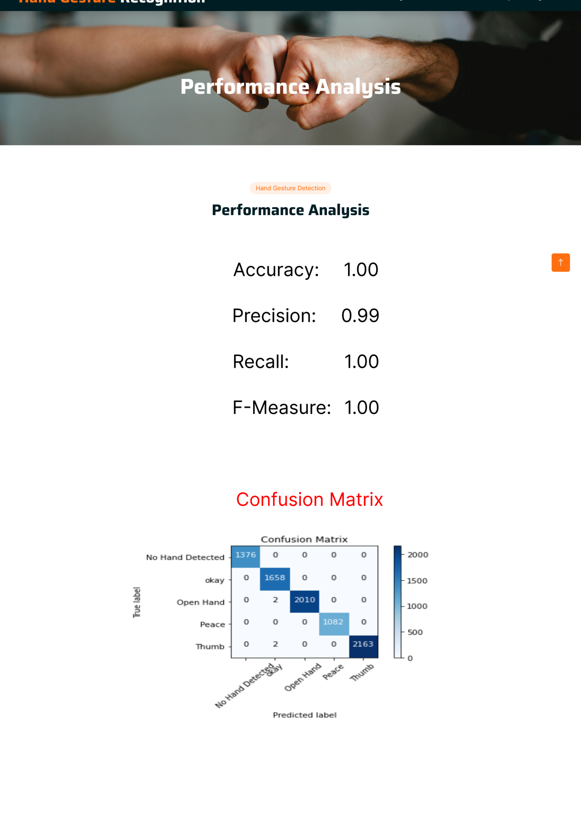

DATA SET:

OK:

OPEN HAND

PEACE:

THUMP’S UP:

NO HAND DETECTED:

OPEN HAND:

PEACE:

OK:

THUMPS UP: